ASSIGNMENT 1

Assignment 1 :Design and develop a website for various clubs in Vishwakarma Institute of Technology using HTML only without support of CSS.

HOME PAGE

<!DOCTYPE html>

<html lang="en">

<head>

<meta charset="UTF-8">

<meta name="viewport" content="width=device-width, initial-scale=1.0">

<title>Aaroha</title>

<style>

body {

font-family: Arial, sans-serif;

line-height: 1.6;

margin: 0;

padding: 0;

background-color: #f4f4f4;

}

header {

background: #35424a;

color: #ffffff;

padding: 20px 0;

text-align: center;

}

nav {

margin: 20px 0;

}

nav a {

color: #ffffff;

text-decoration: none;

margin: 0 15px;

}

.container {

width: 80%;

margin: auto;

overflow: hidden;

}

footer {

text-align: center;

padding: 10px 0;

background: #35424a;

color: #ffffff;

position: static;

bottom: 0;

width: 100%;

}

.content {

background: white;

padding: 20px;

margin: 20px 0;

border-radius: 8px;

}

</style>

</head>

<body>

<header>

<h1><img src="https://encrypted-tbn0.gstatic.com/images?q=tbn:ANd9GcRQ_VdLkRJ7tND6d7Q0t0uarDADzCgHAO5u1Q&s" alt="This is club logo" width="200px" height="200px" > Welcome to the aaroha Club</h1>

<nav>

<a href="http://127.0.0.1:5500/web%20Development/web%20page%20assignment.html">Home</a>

<a href="#about">About Us</a>

<a href="#events">Events</a>

<a href="#join">Join Us</a>

<a href="#contact">Contact</a>

</nav>

</header>

<div class="container">

<div class="content" id="info">

<h2>Aaroha - Music Club</h2>

<p>Music encompasses every aspect of life. Various enthusiasts, performers, students who thought of pursuing a carrer in music need a chance to present themselves, more so, a platform where someone can appreciate their talents</p>

<img src="https://encrypted-tbn0.gstatic.com/images?q=tbn:ANd9GcRQ_VdLkRJ7tND6d7Q0t0uarDADzCgHAO5u1Q&s" alt="this is a image of aaroha" width="33%" height="300px">

<img src="https://i.ytimg.com/vi/vZdWJ_jIKsI/hqdefault.jpg" alt="" width="33%" height="300px">

<img src="https://i.ytimg.com/vi/OtHNsC8fKkY/hqdefault.jpg" alt="" width="33%" height="300px">

</div>

<div class="content" id="about">

<h2>About Us</h2>

<p>We are a community of music lovers dedicated to the art of singing. Whether you are a beginner or an experienced singer,<br> our club offers a supportive environment for everyone to improve their skills and enjoy music.</p>

<iframe src="https://www.youtube.com/embed/PLvWw88efz4?si=8h6gn46Ce5sbl9LI" width="560" height="315" title="YouTube video player" frameborder="0" accelerometer; autoplay; clipboard-write; encrypted-media; gyroscope; picture-in-picture; web-share" referrerpolicy="strict-origin-when-cross-origin" allowfullscreen></iframe>

<br>

<ul>

<li>Aaroha is enthusiasts club </li>

<li>About Us: <a href="http://127.0.0.1:5500/web%20Development/Web%20Developmet%20About%20us.html"> Know more</a></li>

</ul>

</div>

<div class="content" id="events">

<h2>Upcoming Events</h2>

<ul>

<li>Weekly Singing Practice - Every Tuesday at 6 PM</li>

<li>Annual Singing Competition - March 15</li>

<li>Guest Vocal Coach Workshop - April 20</li>

<li>More Events info: <a href="http://127.0.0.1:5500/web%20Development/Web%20Development%20assignmenet%20events.html">More Events</a></li>

</ul>

</div>

</div>

<div class="ending">

<div class="content" id="join">

<h3>Join Us</h3>

<p>If you love singing and want to improve your skills, we invite you to join our club! Fill out the <a href="#contact">contact form</a> below to get started.</p>

</div>

<div class="content" id="contact">

<h3>Contact Us</h3>

<p>If you have any questions or would like more information, please reach out!</p>

<p>Email: <a href="mailto:info@aaroha.com">info@singingclub.com</a></p>

<p>Insta: <a href="https://www.instagram.com/vit_aaroh/" target="_blank"> Aaroha(vit pune)</a></p>

</div>

</div>

<footer>

<p>&copy; 2024 Singing Club. All rights reserved. || validated by RK</p>

</footer>

</body>

</html>

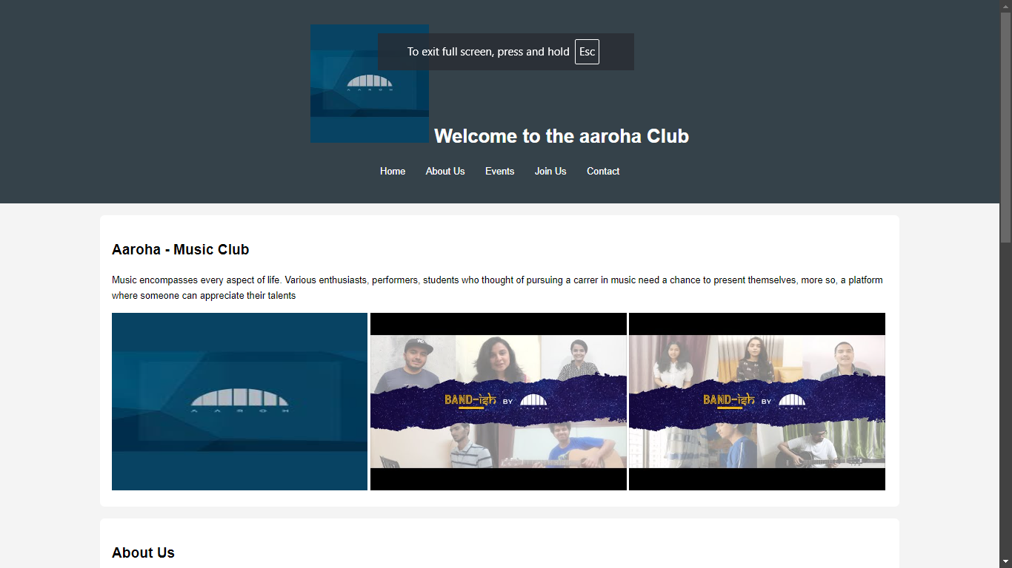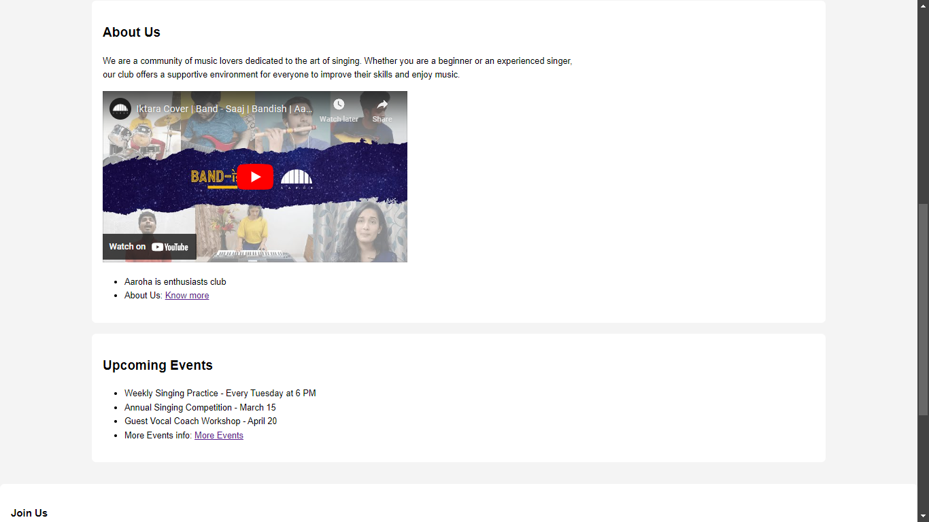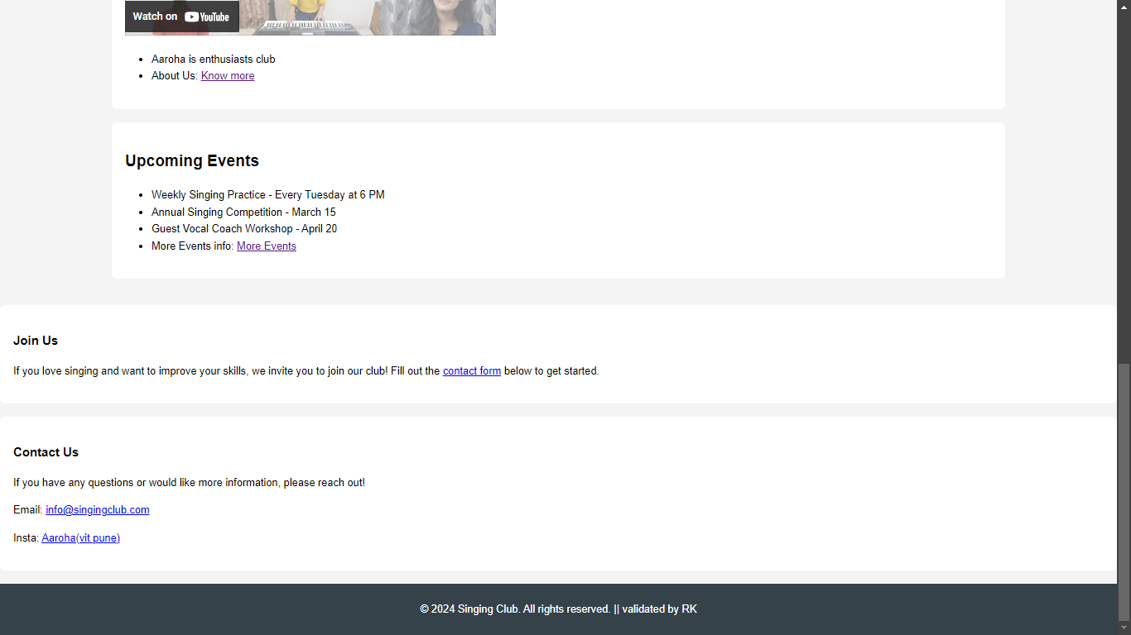

ABOUT US

<!DOCTYPE html>

<html lang="en">

<head>

<meta charset="UTF-8">

<meta name="viewport" content="width=device-width, initial-scale=1.0">

<title>Aaroha</title>

<style>

body {

font-family: Arial, sans-serif;

line-height: 1.6;

margin: 0;

padding: 0;

background-color: #f4f4f4;

}

header {

background: #35424a;

color: #ffffff;

padding: 20px 0;

text-align: center;

}

nav {

margin: 20px 0;

}

nav a {

color: #ffffff;

text-decoration: none;

margin: 0 15px;

}

.container {

width: 80%;

margin: auto;

overflow: hidden;

}

footer {

text-align: center;

padding: 10px 0;

background: #35424a;

color: #ffffff;

position: static;

bottom: 0;

width: 100%;

}

.content {

background: white;

padding: 20px;

margin: 20px 0;

border-radius: 8px;

}

</style>

</head>

<body>

<header>

<h1><img src="https://encrypted-tbn0.gstatic.com/images?q=tbn:ANd9GcRQ_VdLkRJ7tND6d7Q0t0uarDADzCgHAO5u1Q&s" alt="This is club logo" width="200px" height="200px" > Welcome to the aaroha Club</h1>

<nav>

<a href="http://127.0.0.1:5500/web%20Development/web%20page%20assignment.html">Home</a>

<a href="http://127.0.0.1:5500/web%20Development/Web%20Developmet%20About%20us.html">About Us</a>

<a href="http://127.0.0.1:5500/web%20Development/Web%20Development%20assignmenet%20events.html">Events</a>

<a href="#join">Join Us</a>

<a href="#contact">Contact</a>

</nav>

</header>

<div class="container">

<div class="content" id="about">

<h2>About Us</h2>

<p>We are a community of music lovers dedicated to the art of singing. Whether you are a beginner or an experienced singer,<br> our club offers a supportive environment for everyone to improve their skills and enjoy music.</p>

<br>

<p>Aaroha is the official music club at VIT Pune, designed for students passionate about music, whether they are singers, instrumentalists, or just music enthusiasts. The club offers a platform for students to showcase their musical talents, participate in events, and collaborate with fellow musicians.

Aaroha often organizes a variety of activities, including:

- **Live performances**: Concerts, jam sessions, and open mics.

- **Competitions**: Inter-college and intra-college music competitions.

- **Workshops**: Music workshops to enhance skills in vocals, instruments, or music production.

If you're interested in joining, the club likely holds auditions or open registrations at the beginning of the academic year. It’s a great space to connect with like-minded students and grow your passion for music!</p>

<br>

<p><iframe src="https://www.youtube.com/embed/PLvWw88efz4?si=8h6gn46Ce5sbl9LI" width="560" height="315" title="YouTube video player" frameborder="0" accelerometer; autoplay; clipboard-write; encrypted-media; gyroscope; picture-in-picture; web-share" referrerpolicy="strict-origin-when-cross-origin" allowfullscreen></iframe></p>

</div>

</div>

<div class="ending">

<div class="content" id="join">

<h3>Join Us</h3>

<p>If you love singing and want to improve your skills, we invite you to join our club! Fill out the <a href="#contact">contact form</a> below to get started.</p>

</div>

<div class="content" id="contact">

<h3>Contact Us</h3>

<p>If you have any questions or would like more information, please reach out!</p>

<p>Email: <a href="mailto:info@singingclub.com">info@singingclub.com</a></p>

<p>Insta: <a href="https://www.instagram.com/vit_aaroh/" target="_blank"> Aaroha(vit pune)</a></p>

</div>

</div>

<footer>

<p>&copy; 2024 Singing Club. All rights reserved. || validated by RK</p>

</footer>

</body>

</html>

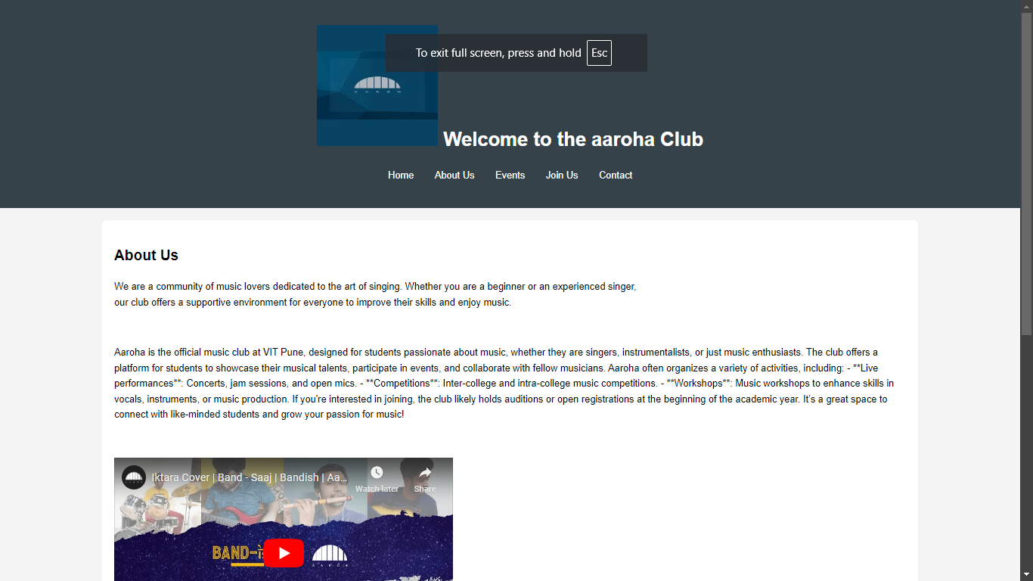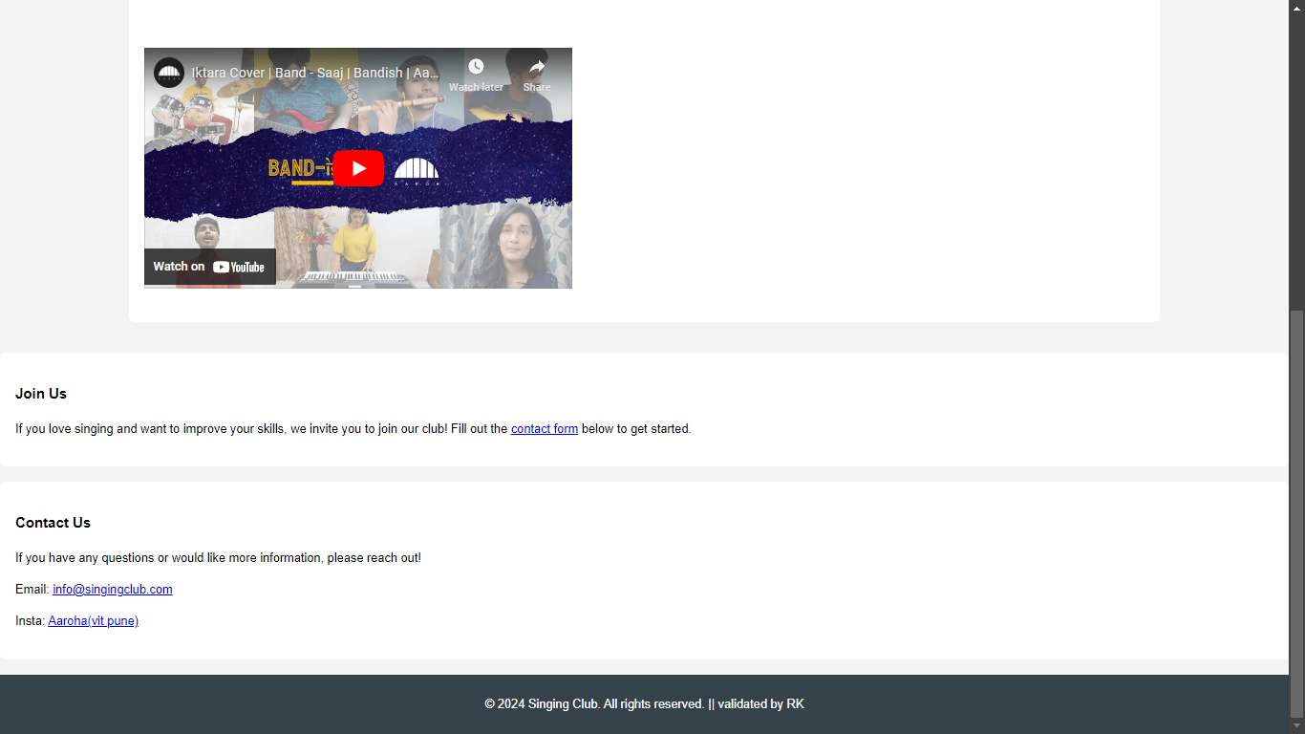

EVENT PAGE

<!DOCTYPE html>

<html lang="en">

<head>

<meta charset="UTF-8">

<meta name="viewport" content="width=device-width, initial-scale=1.0">

<title>Aaroha</title>

<style>

body {

font-family: Arial, sans-serif;

line-height: 1.6;

margin: 0;

padding: 0;

background-color: #f4f4f4;

}

header {

background: #35424a;

color: #ffffff;

padding: 20px 0;

text-align: center;

}

nav {

margin: 20px 0;

}

nav a {

color: #ffffff;

text-decoration: none;

margin: 0 15px;

}

.container {

width: 80%;

margin: auto;

overflow: hidden;

}

footer {

text-align: center;

padding: 10px 0;

background: #35424a;

color: #ffffff;

position: sticky;

bottom: 0;

height: 50px;

width: 100%;

}

.content {

background: white;

padding: 20px;

margin: 20px 0;

border-radius: 8px;

}

</style>

</head>

<body>

<header>

<h1><img src="https://encrypted-tbn0.gstatic.com/images?q=tbn:ANd9GcRQ_VdLkRJ7tND6d7Q0t0uarDADzCgHAO5u1Q&s" alt="This is club logo" width="200px" height="200px" > Welcome to the aaroha Club</h1>

<nav>

<a href="http://127.0.0.1:5500/web%20Development/web%20page%20assignment.html">Home</a>

<a href="http://127.0.0.1:5500/web%20Development/Web%20Developmet%20About%20us.html">About Us</a>

<a href="http://127.0.0.1:5500/web%20Development/Web%20Development%20assignmenet%20events.html">Events</a>

<a href="#join">Join Us</a>

<a href="#contact">Contact</a>

</nav>

</header>

<div class="container">

<div class="content" id="info">

<h2>Events within Aaroha</h2>

<p>Music encompasses every aspect of life. Various enthusiasts, performers, students who thought of pursuing a carrer in music need a chance to present themselves, more so, a platform where someone can appreciate their talents</p>

<br>

<p>Aaroha Music Club at VIT Pune is known for organizing a variety of events throughout the academic year that cater to different aspects of musical expression. Here are some more events they typically organize:

1. **Annual Cultural Fest Performances**:

- Aaroha plays a big part in VIT Pune’s cultural fest, **Melange**. They organize band performances, solo acts, and group performances during the fest, featuring different music genres.

2. **Jamming Sessions**:

- These informal meetups allow members to collaborate, explore new music styles, and experiment with improvisation. It’s a great way for beginners and experienced musicians alike to bond and improve their skills.

3. **Battle of the Bands**:

- A competitive event where various student bands from within and outside VIT Pune battle it out for the title of the best band. It's a high-energy event, with each band bringing their best music to the stage.

4. **Unplugged Nights**:

- These are acoustic music nights where musicians perform unplugged versions of songs. It’s a more relaxed and intimate event, often set in an outdoor venue.

5. **Tribute Nights**:

- Themed events dedicated to legendary artists or bands where members perform covers of iconic songs. Past tributes might have included artists like The Beatles, Queen, or A.R. Rahman.

6. **Music Production Workshops**:

- Workshops where experts in music production teach students how to create their own music using software like FL Studio, Ableton, or Logic Pro. It’s a fantastic learning experience for those interested in the technical side of music.

7. **Open Mic Events**:

- A platform where anyone, not just club members, can perform. These events are typically casual and invite performances from singers, poets, and instrumentalists.

8. **Collaborations with Other Clubs**:

- Aaroha collaborates with other cultural clubs, like the dance or drama clubs, to provide live music for performances. This synergy creates a rich cultural experience during major college events.

These events are great opportunities for students to showcase their talent, learn, and make connections within the music scene at VIT Pune.</p>

<img src="https://encrypted-tbn0.gstatic.com/images?q=tbn:ANd9GcRQ_VdLkRJ7tND6d7Q0t0uarDADzCgHAO5u1Q&s" alt="this is a image of aaroha" width="33%" height="300px">

<img src="https://i.ytimg.com/vi/vZdWJ_jIKsI/hqdefault.jpg" alt="" width="33%" height="300px">

<img src="https://i.ytimg.com/vi/OtHNsC8fKkY/hqdefault.jpg" alt="" width="33%" height="300px">

</div>

</div>

<div class="ending">

<div class="content" id="join">

<h3>Join Us</h3>

<p>If you love singing and want to improve your skills, we invite you to join our club! Fill out the <a href="#contact">contact form</a> below to get started.</p>

</div>

<div class="content" id="contact">

<h3>Contact Us</h3>

<p>If you have any questions or would like more information, please reach out!</p>

<p>Email: <a href="mailto:info@singingclub.com">info@singingclub.com</a></p>

<p>Insta: <a href="https://www.instagram.com/vit_aaroh/" target="_blank"> Aaroha(vit pune)</a></p>

</div>

</div>

<footer>

<p>&copy; 2024 Singing Club. All rights reserved. || validated by RK</p>

</footer>

</body>

</html>

